**Green Society Public School**

**D-24**

**Ratnanagar-7, Sauraha, Chitwan**

**First Terminal Examination-2082**

**Class: One Time: - 1 hr. F.M.: 25**

**Sub: Science**

|  |
| --- |
| **Name: Roll No.: Sec.:** |
| **­­­­­­­­­­­­ ________________ ______________ OBT.MARKS:**  **INVIGILATOR EXAMINER** |

1. **Tick ✔ the best answer from the given alternatives. (5)**
2. Which one is a fruit?
3. banana ii) fish iii) chicken iv) milk
4. Which is one way communication device?
5. laptop ii) mobile iii) computer iv) television
6. Which animal eats plants?
7. Hen ii) cow iii) snake iv) tiger
8. Baby of cow is ________ .
9. Cat ii) puppy iii) kid iv) calf
10. Which one is non-living thing?
11. animal ii) man iii) stone iv) plant
12. **Fill in the blanks by choosing the word from the brackets. (5)**
13. Plants get water from ____________________. (ground/ air)
14. Plants __________________ if we do not water them. (grow/ die)
15. There are ____________________ types of things. (two/ three)
16. Car is __________________ things. (living/ non-living)
17. A _________________ grows to be a cat. (kitten/ puppy)
18. **Write ‘T’ for true and ‘F’ for false. (5)**
19. There are three types of things.
20. All living things need food.
21. All living things cannot grow.
22. Plants are living things.
23. Car is a living thing because it can move.
24. **Write the name of two living things. (2)**
25. ____________ b)____________
26. **Write the name of two non-living things. (2)**

a)_____________ b)____________

1. **Write the name of two animals that lay eggs. (2)**

a)_____________ b)_____________

1. **Fill in the blanks. (2)**
2. Pup______y b) Kitte______ c) bo______k c) P______ant

1. 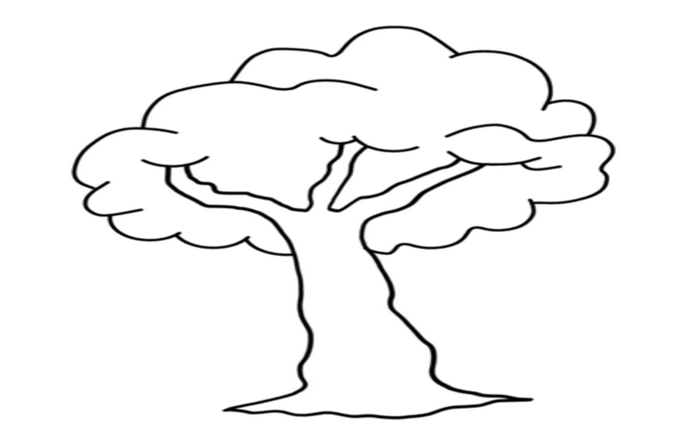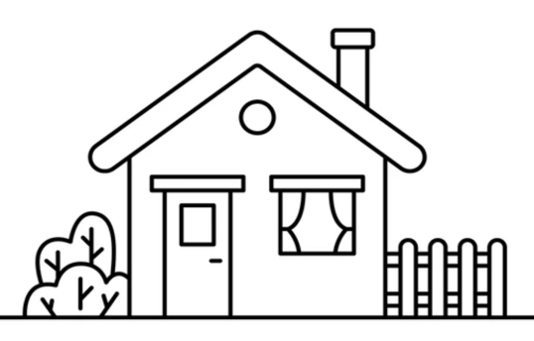**Write the name of following pictures. (2)**

**The End**